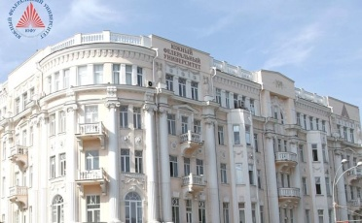

Southern Federal University (Rostov-on-Don, Russia)
invites you to take part in the V International scientific forum
"The integrative approach in the prevention of addictions in youth in the context of digitalization", which will be held from 6 to 7 December 2018

The goal of the conference is to discuss and find ways of solving urgent scientific and practical problems of prevention of addictions among young people, strategies, criteria and methods of research, integration of scientists and practitioners, scientific, state and public organizations in the prevention of addictions among young people in modern multicultural society.
During the scientific forum will address the following questions:
- Technology to promote results of research activities of the University in the activities of public organizations of the preventive orientation;
- Psycho-educational and psychotherapeutic aspects in ensuring quality prevention of dependency among the youth;
- Improving the system of family education in the prevention of dependency in youth and student's environment;
- Prevention of threats to the health of young people in the network
- Health saving technologies in the prevention of dependency among the youth;
- Prevention of extremism in the youth environment as a new form of dependence;
- Innovative research in the area of dependency prevention and new types of dependencies
To participate in the IV International scientific and practice conference invited graduate students, degree seekers, researchers, doctoral students, University professors, experts in the field of youth policy of the southern Federal district, sociologists, political scientists, journalists, health workers, pedagogical workers of educational institutions of all types and educational levels, teachers, psychologists, students, practitioners, public figures, representatives of public organizations and foundations, the commanders of the volunteer youth groups, and individuals interested in the issues of prevention of addictions in youth.
Working languages of conference – Russian, English.
To participate in the conference should complete the application form.
The deadline for submitting papers for publication at 22.00 expires November 28, 2018. According to the results of the conference will be published scientific papers with mandatory distribution to leading libraries of pedagogical Universities of the Russian Federation.
Conference participation – full-time study.
Applications for participation and abstracts (volume of submissions max. 7 000 characters with spaces), executed in accordance with the following requirements will be accepted via email: forumprofilaktica@yandex.ru until November 28, 2018.

The application for participation in the IV International scientific forum
"The integrative approach in the prevention of dependency
in the youth environment".
Name

Country

The city

Name of the organization

The post

Academic degree/academic title

Topic

E-mail address

The form of participation in the forum

Requirements to registration of materials of reports
The volume of publication – up to 10 000 characters. With the sponsorship of the personal contribution of each author should be at least 3000 characters.
The text of the article includes:
– Name, position, degree, title, place of work or study (in Russian and English);
the title of the article (in Russian and English);
– abstract (50 words) (Russian and English);
– key words (5-10) (in Russian and English);
- text;
– references to the article (from 5 to 10 names of sources that were referenced in the text) – in Russian and English languages

